CRIME RECORD MANAGEMENT SYSTEM SOFTWARE

Authors:- Devraj Naik, Ramakanta Mishra, Bithal Ray, Faizan Riaz

Date:-4/dec/2023

Document version:1.0

Sri Sri University Project

Introduction:-

Purpose of this document:

This document help users who use this software to operate it interactively

General Desc:

This is a fully functional crime record management software

Made with Python3 and MYSQL which is used to work with crminal records. It help jailers,Police officers,Intelligence officers to fetch any criminal record in fingertips. This software meet all the requirements of Nascoom rules and regulations for developing modern software policy. This software have ability to store criminal name, his father’s name, Mother’s name, Case number, Crime name and other details. This software have a about section through which you can learn more about software. It contains a search option through which you can search for a particular criminal. It contains safety tips for users

FUNCTIONAL REQUIREMENTS:

\*PYTHON3(python3-tkinter module,PIL module,mysql-connector module,Operating system(os) module

->Tkinter module is used to build interactively GUI Applications.

->PIL module can load image files directly from

Computer which can be used in software

->Mysql connector is used to connect python to a MYSQL DATABASE. In mycon you can specify hostname,username,password and database name.

\*MYSQL(MYSQL 5.7 OR HIGHER REQUIRED including mysql cli,mysql server,mysql workbrench)

INTERFACE REQUIREMENTS

This software uses os module to execute sub programs about this software. Before using this software make sure you are connected with the right database which have ability to store and fetch records.

PERFORMANCE REQUIREMENTS

This software can be configured and run on any system that’s having min i3 8th Gen Processor, 8GB ram and minimum 20GB of free memory.

LOGICAL DATABASE REQUIREMENTS

MYSQL Database having a database name “crm” and table name “crm” in which records are stored.

Database structure should be like below:

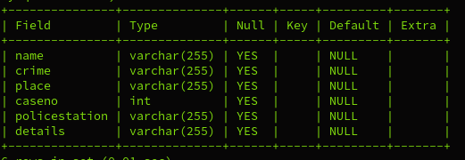

OPERATING MANUAL

->From the login page Enter correct name and Password which required to open this project.

->After entering correct details click on the Login Button

->The login page should be like below

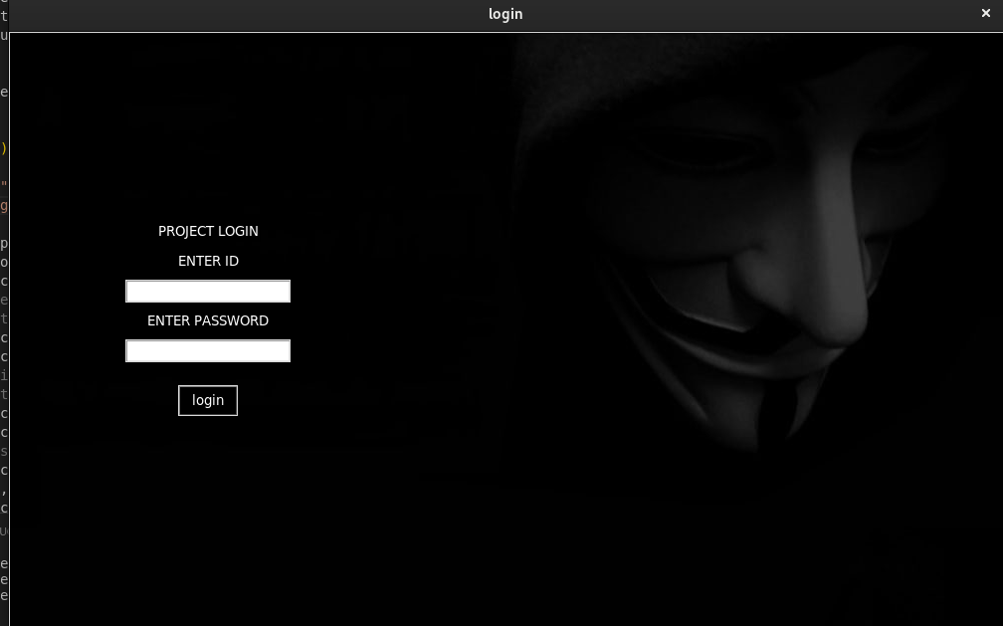

->Then You will be Redirected to the main page of Crime Record Management Software Which have all the functionalities to operate the Software.

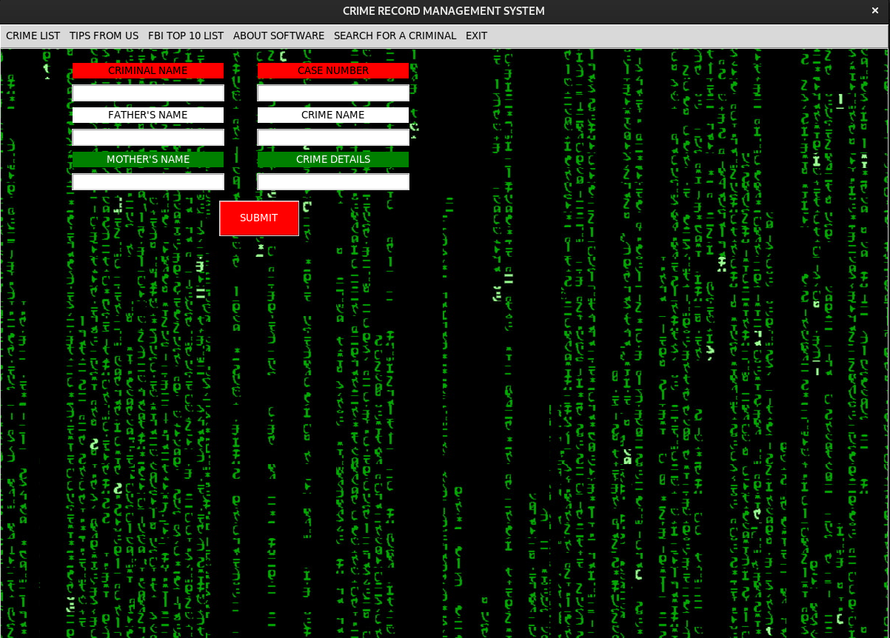

->click on “CRIME LIST” to see all existing criminal records.

->click on “TIPS FROM US” to get safety Tips

->click on About software to find Software and company information

->click on “SEARCH “ option to search for a particular record

It should be like below image.

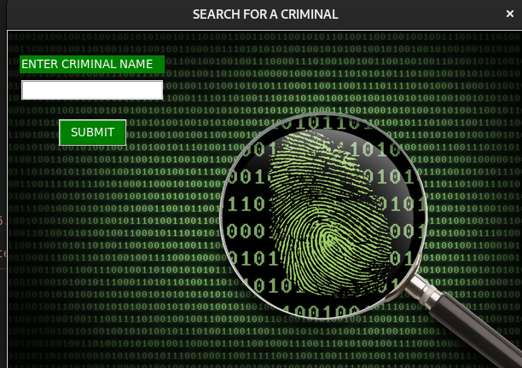

->Enter a criminal name to find his information and it will be displayed through a table.

NEW CRIMINAL ENTRY

->On this page you will see many lebels asking for particular criminal information.

->You can Fill it then click on Submit button.

->Records will be Stored to MYSQL database.

->Any officer working in police or similar department can load these records and manipulate it.

SAFETY REQUIREMENTS

->Keep this software away from unauthorized peoples

->use it according government guidelines and policies.

->Do not try to Reverse Engineering this software. It may violate Nasscom Software copyright guidelines.

DEVELOPER INFORMATION

NAME:- Manoj Kumar Jena

SRI SRI UNIVERSITY

Email:-[Manojjena5802@gmail.com](mailto:Manojjena5802@gmail.com)

Cuttack,Odisha,india

Pin code:- 754006

For more clarification you can write us:

[Manojjena5802@gmail.com](mailto:ramakantmishra075@gmail.com)

CRIME RECORD MANAGEMENT SYSTEM

VERSION 1.0

COPYRIGHT 2022